**RC Circuit**

[Modified from PASCO lab manual #78]

**Pre-lab questions:**

1. What is the goal of this experiment? What physics and general science concepts does this activity demonstrate?
2. Show that the capacitive time constant RC has units of seconds.
3. If the capacitance in the circuit is doubled, how is the half-life affected?
4. If the resistance in the circuit is doubled, how is the half-life affected?
5. If the charging voltage in the circuit is doubled, how is the half-life affected?
6. To plot the equation so the graph results in a straight line, what quantity do you have to plot vs. time? What is the expression for the slope of this straight line?

**Equipment:**

* PASCO 850 universal interface
* PASCO Capstone software
* Resistor-Capacitor-Inductor Network
* PASCO voltage sensor
* Patch cord set

The goal of the experiment is to study how the voltage decreases on a capacitor in a resistor-capacitor circuit. The half-life of the decay is measured experimentally and also calculated from the capacitive time constant.

**Introduction:**

Capacitors are circuit devices that can store charge. The capacitance of the capacitor is a measure of how much charge it can hold for a given voltage.

$$\begin{aligned}Q=CV_{c}\#\left(1\right)\end{aligned}$$

where *C* is the capacitance in Farads, *Q* is the charge in Coulombs, and *VC*is the voltages across the capacitor in Volts.

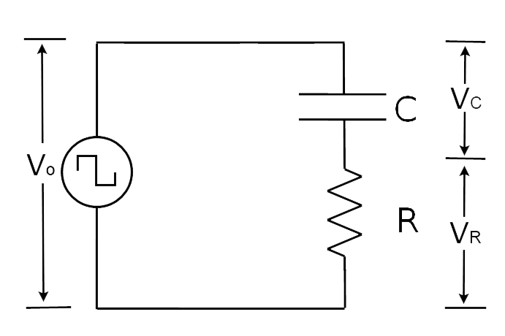

Figure 1: RC circuit schematic with voltages indicated. From PASCO lab #78.

The goal of the experiment is to study the behavior of *VC*, the voltage across the capacitor, as it discharges. To predict this behavior, we can write a Kirchhoff’s Loop equation for the circuit shown in Figure 1.

$$\begin{aligned}V_{0}=V_{C}+V_{R}\#\left(2\right)\end{aligned}$$

Equation 1 can be solved for the voltage across the capacitor, and we know that the voltage across a resistor is given by Ohm’s Law:

$$\begin{aligned}V_{R}=IR\#\left(3\right)\end{aligned}$$

When the capacitor is discharging, the applied voltage *V0*is zero, and the current can be expressed as the change in charge per unit time $\frac{∆Q}{∆t}$ or in notation for instantaneous current $I=\frac{dQ}{dt}$.

Substituting all of this into the Kirchhoff’s Loop equation (2), we have the expression:

$$\begin{aligned}0=\frac{Q}{C}+R\frac{dQ}{dt}\#\left(4\right)\end{aligned}$$

Rearranging, we get a differential equation for the charge on the capacitor:

$$\begin{aligned}\frac{dQ}{dt}=-\left(\frac{1}{RC}\right)Q\#\left(5\right)\end{aligned}$$

The solution to this differential equation is:

$$\begin{aligned}Q=Q_{max}e^{-\left(t/{RC}\right)}\#\left(6\right)\end{aligned}$$

This an expression for the charge leaving the capacitor as a function of time as the capacitor discharges. However, we would like to study the voltage across the capacitor. Luckily, we can predict that behavior from equation 6 and equation 1:

$$\begin{aligned}V_{C}=\frac{Q}{C}=V_{0}e^{-\left(t/{RC}\right)}\#\left(7\right)\end{aligned}$$

where $V_{0}=Q_{max}/C$.

Equation 7 tells us that the rate that voltage across a capacitor (and the charge stored in the capacitor) decreases depends on the resistance and capacitance that are in the circuit. If a capacitor is charged to an initial voltage *V0*, and is allowed to discharge through a resistor, *R*, the voltage, *VC*, across the capacitor will decrease exponentially.

The half-life of an exponential decay, *t1/2*­, is defined as the time for the magnitude of the decaying quantity to decrease by half. In this case, that decaying quantity is the voltage across the capacitor:

$$\begin{aligned}V\left(t_{1/2}\right)=\frac{V_{0}}{2}=V_{0}e^{-\left({t_{1/2}}/{RC}\right)}\#\left(8\right)\end{aligned}$$

Rearranging equation 8, we need to use the natural log to solve for the half-life, *t1/2*­.

RC is called the capacitive time constant and has the units of seconds. You can see from equation 9 that the choice in magnitude of the resistor and capacitor in an RC circuit will affect the time to discharge the capacitor.

## Experiment:

***Set up:***

1. Construct the circuit shown in Figure 2.
   1. The voltage source is signal generator #1 on the PASCO 850 Universal Interface.
   2. C = 3900 pF and R = 47 kΩ 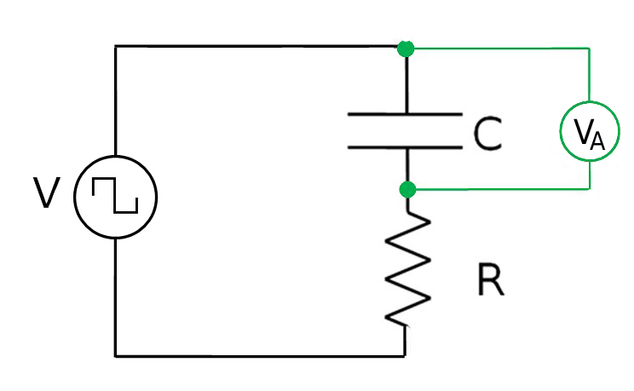

Figure 2: RC circuit diagram for experiment set up.

1. In the PASCO Capstone software, click on Signal Generator #1 to connect the internal Output Voltage-Current Sensor.
   1. Set the signal generator to a 350 Hz positive square wave with 4 V amplitude.
   2. Set the signal generator on Auto.
2. Plug the voltage sensor into channel A
   1. Connect the voltage sensor across the capacitor.
   2. Set the voltage sensor in the hardware set up in PASCO Capstone software.

***Procedure:***

**Part A**

1. Set up an oscilloscope display with the Voltage Ch.A and the Output Voltage on the same axis.
2. Select the Fast Monitor Mode.
3. Click Monitor and adjust the scale on the oscilloscope so there is a complete cycle, so the capacitor fully charges and discharges.
4. Increase the number of points (using the tool on the scope toolbar) to the maximum allowed. Then take a snapshot of both voltages shown. Rename the snapshots "3900pF – 4V".

**Part B – Increase the Voltage**

1. Increase the voltage amplitude to 8 V.
2. Keep the circuit components the same.
3. Repeat the procedure described in part A. Name your snapshot “3900pF – 8V”.

**Part C – Decrease the Capacitance**

1. Return the output voltage to 4 V.
2. Change the frequency of the signal generator to 1800 Hz.
3. Replace the 3900 pF capacitor with a 560 pF capacitor.
4. Repeat the procedure described in part A. Name your snapshot “560pF – 4V”.

**Data:**

Include a snapshot of the voltages for each procedure part in your lab report. Be sure to include axis labels and a legend.

**Computations, and Analysis Part A:**

1. Create a graph with Voltage Ch.A and the Output Voltage vs. time. Select the voltages for the 3900 pF run on the graph.
2. Using the Coordinates Tool, measure the time it takes for the voltage to decay to half of its maximum. This time is the half-life. [It may be necessary to reduce the snap-to-pixel distance to 1 in the properties of the Coordinates Tool (right click on the tool to access the properties).]
$$t_{1/2}=__________________$$

3. Measure the time it takes for the voltage to decay to one-quarter of its maximum. This is two half-lives. Then divide this time by two to find the half-life.
$$2*t_{1/2}=__________________$$

$$t_{1/2}=__________________$$

4. Measure the time it takes for the voltage to decay to one-eighth of its maximum. This is three half-lives. Then divide this time by three to find the half-life.
$$3*t_{1/2}=__________________$$

$$t_{1/2}=__________________$$

5. Take the average of the three measured values of the half-life. Estimate the precision of the measurement and state it as {half-life ± precision}.

experimental $t_{1/2}=__________________±___________________$

1. Calculate the theoretical half-life given by Equation (9) and compare it to the measured value using a percent difference.

theoretical $t_{1/2}=__________________$

**Computations, and Analysis Part B:**

Repeat the analysis steps described in part A.

|  |  |  |
| --- | --- | --- |
| Step 2 result: |  | $$t_{1/2}=$$ |
| Step 3 result: | $$2t_{1/2}=$$ | $$t_{1/2}=$$ |
| Step 4 result: | $$3t_{1/2}=$$ | $$t_{1/2}=$$ |
| Step 5 result: | Average experimental with uncertainty | $$t_{1/2}=$$ |
| Step 6 result: | Theoretical | $$t_{1/2}=$$ |

**Computations, and Analysis Part C:**

Repeat the analysis steps described in part A.

|  |  |  |
| --- | --- | --- |
| Step 2 result: |  | $$t_{1/2}=$$ |
| Step 3 result: | $$2t_{1/2}=$$ | $$t_{1/2}=$$ |
| Step 4 result: | $$3t_{1/2}=$$ | $$t_{1/2}=$$ |
| Step 5 result: | Average experimental with uncertainty | $$t_{1/2}=$$ |
| Step 6 result: | Theoretical | $$t_{1/2}=$$ |

**Conclusions:**

1. Summarize how changing the voltage and capacitance changes the half-life.
2. Include the values found for the half-lives and the % differences. Does the theoretical value lie within the range of precision of your measurements? Explain what causes the differences.
3. Did your answers to the Pre-Lab Questions agree with the results?

**Sources of errors:**

What assumptions were made that caused error? What is the uncertainty in your final calculation due to measurement limitations?